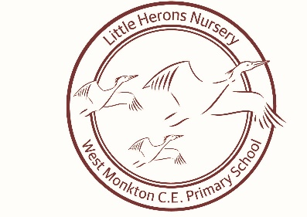 PSHE Newsletter
PSHE in early years is taught through a variety of adult led and child initiated activities.
The interests of the individuals in the setting guide all activities and play based learning opportunities. PSHE forms the basic structure of the EYFS with numerous opportunities for the children to develop within each of the strands.
PSHE is taught in three main strands;
- ‘Health and self-care’
Children know the importance for good health of physical exercise, a healthy diet as well as talking about ways to keep healthy and safe. The children are supported to manage their own basic hygiene and personal needs, including dressing and going to the toilet independently.
- ‘Making relationships’
Children are supported to play co-operatively and take turns with others through the use of now and next and respecting others play by allowing them to finish. Where necessary a visual aid is used such as a timer to support.
Children take account of one another’s ideas about how to organise or structure their activity, they are also supported to show sensitivity to others needs and feelings with the use of visual aids where necessary to support forming positive relationships with adults and other children.
- Managing feelings and behaviour’
Children talk about how they and others show feelings, talk about their own behaviour and are supported to problem solve where conflict occurs, this supports them to recognise that whilst all feelings are acceptable not all behaviours are.
They work as part of a group as an individual to understand and follow rules. They adjust their behaviour to different situations to eventually take changes of routine in their stride.

There are many ways that children can be supported with each main strand such as: through fun and exciting activities, stories and by asking open questions.
What is an open question?
Open questions are questions that require the participant to answer in their own words.
An open question is question that cannot be answered with a ‘yes’ or ‘no’

Oral Health Week
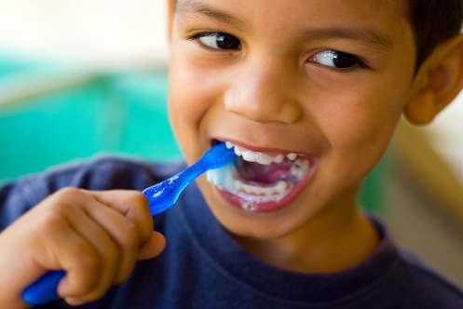

Little Herons are participating in an Oral Health week on the week commencing 31st October.
To support this, we will be looking at who/what keeps our teeth healthy and clean. We will also be exploring occupations such as dentists, dental nurses, hygienists and doctors.
We have many exciting activities planned as well as songs and stories to encourage keeping teeth healthy and clean. This also includes looking at what foods are good or bad for keeping teeth healthy.
We would encourage you to discuss these choices with your child at meal times and when packing lunch boxes.

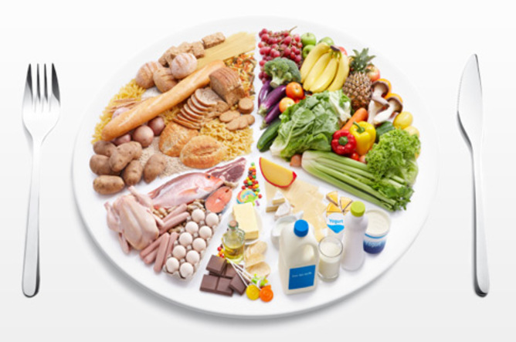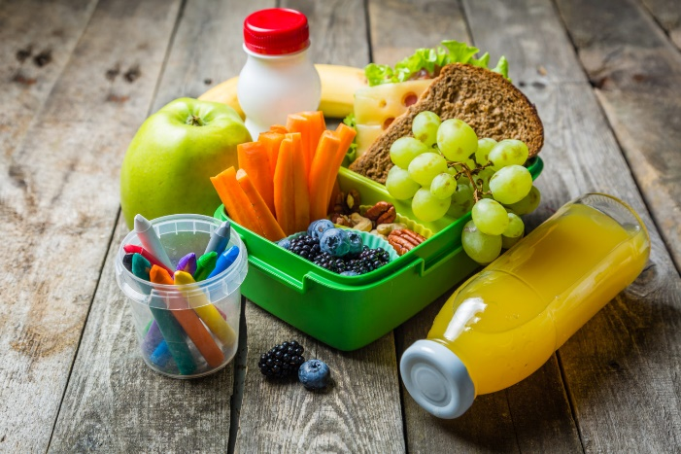

When to visit the dentist?
It is recommended that you have regular check-ups at the dentist as soon as your milk teeth appear as per the NHS guidance. If your child is not yet registered at a dental practise, we would encourage you to register and book an appointment as soon as possible.
Please click the links below for further details on children’s teeth and dental check-ups.
https://www.nhs.uk/live-well/healthy-teeth-and-gums/taking-care-of-childrens-teeth/
https://www.nhs.uk/live-well/healthy-teeth-and-gums/dental-check-ups/


There are many ways that you can support your child at home to develop their personal, social, emotional and health education.
Please see activity sheets attached to help encourage you to support your child at home.
We would welcome photos and images of your child participating in activities that support their personal, social, emotional and health development such as my visit to the dentist, brushing me teeth, trying new and healthy foods, showing kindness, meeting new friends and making good choices.
We will display these photos on our topic board to spark conversations and recognise each individual.
Stacie Anthony-Phillips
Little Herons Nursery Manager


What does ‘kindness’ look like?
We talk a lot with children about being kind, but what does kindness look like?

We can try and notice kindness with children and talk about it when we see it.
You could choose a day to look for kindness together.
You might notice:
Mummy being kind to Nanna when she does some shopping for her.
Children being kind to each other at the park, taking turns on the slide.
A brother or sister being kind and reaching up high to get some toys off the shelf.
Sharing and taking turns when you’re playing a game.
Giving someone a hug when they’re feeling sad.
Sharing a biscuit because there is only one left.

You might see kindness on TV. Or you might see it in a picture book. On the bus, at the supermarket, looking out of your window. It might be your child who has been kind, or someone else.

Notice kindness together. Talk about what you seen happening - what the kind action is (e.g. taking turns; doing nanna’s shopping). And why it’s kind (e.g. taking turns means everyone gets a go; doing nanna’s shopping means she doesn’t have to carry the heavy bags home).
You could talk about how kindness feels. Kindness means we feel cared for and included. When someone is kind to you, how do you feel? Use lots of words to describe feelings. This will help your child to find words to tell you how they feel.

Earlier Stages of Development
Use facial expressions and gestures to show a child the good feelings that come from kindness. Clap your hands, smile, hug them. Name the kindness when you see it: That was so kind, Meena shared the book with you. Say ‘one for me, one for you’ when you’re sharing slices of fruit/snacks, or with toys.

What I like about me is…
This activity is all about feeling positive about yourself! It also involves some turn taking and getting to know each other too. (PSED - Self Confidence and Self Awareness, PSED - Making Relationships, PSED – Managing Feelings and Behaviour).
You will need:
Something to pass to each other (a pebble, cushion or a toy)
You and your child – and anyone else who would like to join in

- Start by introducing the object that you will be passing to each other. Explain that when someone is holding the cushion/toy then it is their turn.
- Model starting, and begin by saying ‘What I like about me is… I have green eyes’. Pass the object to your child and ask ‘What do you like about yourself?’ If they are unsure what to say you could support them by saying ‘What I like about you is…you have curly hair.’ Let your child know that it’s okay if they don’t want to say something.
- Keep going between the two of you, or with other players if they are joining you. You can choose different kinds of things: I like that I can touch my toes/ sing/ draw cars/ put my socks on.

Earlier stages of development
Use facial expressions and gestures like clapping to join in with your child’s sense of achievement when they do something like pull up to standing or reach for a toy. Let your child know when they do something amazing!

Extension Ideas
Make up silly songs together or little sayings about what you like about each other: I like you because you give me cuddles doodoobeedoo! or You can touch your toes, I can touch my nose, we can touch our elbows and we’re so clever! Use the object to play other turn taking and sharing games: pass the cushion and say your favourite colour or food, tell the other person what you like about them, turn it into a feelings game – I feel happy today because…


Living is Learning
Getting Dressed
Time to wake up and get dressed! This is something your child will be doing every day and it is the perfect moment to help them develop some coordination (Physical Development: Moving and Handling) and independence (Physical Development: Health and Self Care).

You will need:
Your child!
Their clothes!

- You and your child can decide together what they are going to wear today using lots of talk. Is it hot or cold? Socks or bare feet? Green or blue? Stripes or dinosaurs? (Communication and Language: Speaking, and Understanding). What to wear can sometimes be a moment of conflict – you could try offering your child two T shirts (that you have suggested) and give them the choice (so they feel in control) (Personal, Social and Emotional Development: Managing Feelings and Behaviour).
- Now it’s time to put those clothes on. Be there to support your child, but also allow them to have a go themselves. Every child is different, and you know your child best, so pick up on their signals for when they need a bit of help.
- Balancing – trousers are good for this! (Physical Development: Moving and Handling)
- Finger pincers – buttons and zips are tricky, but good for this (Physical Development: Moving and Handling)
- Big arm movements – T shirts and jumpers are good for this (Physical Development: Moving and Handling)
- Bending and stretching – socks are good for this (Physical Development: Moving and Handling)
- Hopefully you now have a child who is more or less dressed!

Earlier learning opportunities:
If your child is at the stage where you are dressing them, help them move their legs and arms with big stretches. Get them to wiggle their fingers and toes. (Physical Development: Moving and Handling). Use lots of talk – including body parts and clothes (arms, legs, socks, jumper) (Communication and Language: Speaking, and Understanding). Use lots of facial expression and eye contact as you dress them (Personal Social and Emotional Development: Making Relationships).

Extension ideas:
Challenge your child to get dressed as quickly as they can. You could set a timer on your phone, or time them with a clock (Physical Development: Moving and Handling). Start with a longer time and make it a little bit less every day. Use simple time vocabulary – ‘Can you get dressed in 5 minutes today?’ or ‘Yesterday you did it in 5 minutes, can you get dressed in 4 minutes today?’ (Mathematics: Shape, Space and Measure). Can they help a younger sibling to get dressed? (Personal Social and Emotional Development: Making Relationships).

Social stories

Social stories are a way to help children to understand how to manage certain situations that they may be finding difficult. It could be around being kind to a sibling or friend, or helping them to understand why someone they care about is away. There are lots of other scenarios in which they can be used.
The best thing about social stories is that they are entirely personal; and don't need to be presented in any particular way. You could create a digital story on a computer or tablet or make one using paper and pens. They can be created collaboratively and because the main character is often the child in question they are usually fun to share.
An example of a short social story might be:
'Isabelle is 2 and loves her brother very much. Sometimes when her brother is playing with a toy she likes this can make her feel frustrated and sad. When Isabelle is frustrated she sometimes hurts her brother by pushing or hitting him. This makes her brother cry. If Isabelle wants a toy that her brother is playing with she can tell Mummy or Daddy that she would like to play, then they can help everyone to play together'.
You can read a social story with your child together as you would at any other story time. It is an opportunity to talk more about scenarios and emotions and help your child to understand alternative ways to regulate their emotions. It might be an idea to include props like soft toys or even sensory elements (e.g. a scarf with mummy's perfume on that we can smell when she isn't here). The main aim is that the story addresses the emotional challenges that your child is facing. Have fun getting creative!

