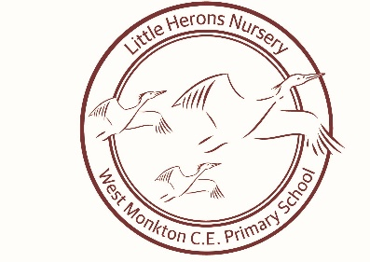 PSHE Newsletter

Welcome to the second edition of our Personal, Social and emotional newsletter. Within this newsletter we will be covering the second strand within the Personal, social and emotional development ‘Making Relationships’, within the Early Years Foundation Stage.
PSHE in early years is taught through a variety of adult led and child initiated activities.
The interests of the individuals in the setting guide all activities and play based learning opportunities. PSHE forms the basic structure of the EYFS with numerous opportunities for the children to develop within each of the strands.
PSHE is taught in three main strands;

- ‘Health and self-care’
Children know the importance for good health of physical exercise, a healthy diet as well as talking about ways to keep healthy and safe. The children are supported to manage their own basic hygiene and personal needs, including dressing and going to the toilet independently.

- ‘Making relationships’
Children are supported to play co-operatively and take turns with others through the use of now and next and respecting others play by allowing them to finish. Where necessary a visual aid is used such as a timer to support.
Children take account of one another’s ideas about how to organise or structure their activity, they are also supported to show sensitivity to others needs and feelings with the use of visual aids where necessary to support forming positive relationships with adults and other children.

- Managing feelings and behaviour
Children talk about how they and others show feelings, talk about their own behavior and are supported to problem solve where conflict occurs, this supports them to recognise that whilst all feelings are acceptable not all behaviours are.
They work as part of a group as an individual to understand and follow rules. They adjust their behaviour to different situations to eventually take changes of routine in their stride.

There are many ways that children can be supported with each main strand such as: through fun and exciting activities, stories and by asking open questions.

What is an open question?
Open questions are questions that require the participant to answer in their own words.
An open question is question that cannot be answered with a ‘yes’ or ‘no’

Making Relationships

Introduction Personal, Social and Emotional Development (PSED), along with Communication and Language (CL) and Physical Development (PD), is one of the three prime areas of learning in the EYFS framework. These areas are called prime because they underpin all other aspects of young children’s learning and development. From the moment they are born, young children experience the world through interacting and communicating with others, and engaging physically with the environment around them. The three prime areas of learning are regarded as particularly important for inspiring young children’s curiosity and enthusiasm, laying the foundations for future success in all aspects of life and education.
Personal development is about how children come to understand who they are and what they can do.
Social development covers how children come to understand themselves in relation to others; how they make friends, understand the rules of society and behave towards others.
Emotional development is about how children understand their own and others’ feelings and develop their ability to be empathetic – to see things from another person’s point of view. In the EYFS, Personal, Social and Emotional Development covers three key aspects:

Prime and specific areas of learning
The three prime areas of the EYFS should be the focus for practitioners working with the youngest children, as they form the basis for successful learning and progress in the four specific areas.
As children become older, the emphasis will shift towards an equal focus on all areas of learning as children’s confidence and abilities increase.
If at any time a child’s progress within any of the prime areas gives cause for concern, practitioners should discuss this with the child’s parents and provide focused support in that area. This approach is designed to ensure that any issues are addressed at an early stage of a child’s life.

Helping children to make relationships
For practitioners, supporting young children in making relationships involves helping them to:
- form positive relationships and develop respect for others
- Understand how to behave appropriately in groups.
Relationships lie at the heart of all human experience and interaction. It is therefore vitally important that young children are helped to learn the social skills needed to interact successfully with other people. They also need lots of opportunities and encouragement to begin to look at the world from the perspective of others and to develop empathy.
The value placed on children knowing how to behave appropriately in groups comes from socio-constructivist theories of learning and development, which place an emphasis on learning being a social experience where the individual learns from more experienced others – children and adults. This means that children who have the skills to interact well with other people can tap into a huge resource to support their learning.
Progress in PSED: Making relationships
24-36 months
Children seek out others to share experiences. They play alongside others and can be caring towards each other.
36-48 months
Children can play in a group. They demonstrate friendly behaviour, initiate conversations and form good relationships with peers and familiar adults.
Early Learning Goal
Children play cooperatively, taking turns with others. They take account of one another’s ideas about how to organise their activity. They show sensitivity to others’ needs and feelings, and form positive relationships with adults and other children. [Statements from Draft EYFS Framework, 2011]

The relationship between Personal, Social and Emotional Development and the other prime areas of learning
‘Personal, Social and Emotional Development supports Physical Development as a child who feels secure and safe is confident to expand the boundaries of exploration and is motivated to reach, move and test physical capacities; it supports Communication and Language within relationships which establish turn taking, joint activity, a desire to communicate and understanding of shared meanings of words.’

Summary of development for two-year-olds
When a child is aged between 24 and 36 months, practitioners must review progress in Personal, Social and Emotional Development, along with the other two prime areas of learning. Parents or carers should be given a short written summary of their child’s development as part of the ongoing dialogue between the setting and the family. This summary should identify any areas where the child’s progress is less than expected and should shape a targeted plan to support that child’s future learning and development in the setting.
There will be no standard format for this developmental summary; instead it should reflect the culture and ethos of the setting and the particular needs of the child and/or parental preferences.

What quality looks like in practice
The following short scenarios describe the environment and practice in a large day nursery in a new purpose built building, catering for children from two to five years of age.

Two- to three-year-olds
Practitioners work together supportively to facilitate the smooth running of the day. They share ideas and resources so that all children can have access to experiences and activities that interest them. In this way, they act as good role models for the children, demonstrating the benefits of teamwork and cooperation.

Mealtimes are an important social occasion, with children and adults sitting together in small groups. This is an occasion for conversation and an opportunity for the children to feel the advantages of being part of a social group. As well as having an open area for running around, the outdoor space has a den and a small house which the children enjoy playing in, often in twos or threes with special friends. Practitioners are alert and observant of the children’s interests out of doors, and use every opportunity to reinforce positive interactions between children.

As children become older and progress through the nursery, care is taken to manage these transitions sensitively to ensure continuity for children. Friendships between children are encouraged and supported and practitioners devote time to helping children to develop the skills they need to manage these well.
Fathers are encouraged to play an active role in their children’s lives and are involved in the life of the nursery through activities such as Fathers First play sessions.

Four- to five-year-olds
The physical environment is resourced in a way that enables children to be independent and to select the resources they want to use. Practitioners are consistent in their attitudes towards children having a responsibility for looking after these resources and putting them back tidily when they have finished with them.

Each day begins with a group time, when children and adults talk together about what the children will do during the coming day. The children discuss what resources and toys they might want to use, where they would like to play and who they would like to play with. This is an opportunity to reinforce the value of cooperation and consideration for others as well as being a useful way to tune in to the children’s ideas and interests. Children frequently play and work together in small groups of four or five, sharing skills and ideas and learning from one another.

Staff model positive relationships in their attitudes to one another and in the language they use with colleagues. They engage positively with parents at the beginning and end of the day and share information with them, helping children to see the positive relationship that exists between the important adults in their lives. .

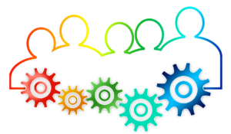
How to support young children in making relationships
Use these reflective questions to think about how you might help young children to develop strong positive relationships with other children and adults.

Under twos
- Do we know how effective our ‘settling in’ processes are for new children and families?
- How well do we understand the benefits of key person working, and do we implement this approach well?
- How effective are our back-up procedures if a key person is absent or on holiday?
- Do we know if our environments are welcoming and reassuring – for adults as well as children?
- How well do we all understand the importance of body language, eye contact and tone of voice?
- How often do we organise activities and experiences that enable children to see the benefits of cooperating with one another?
- Do we all feel confident in interacting with the parents of our key children?
- Should we spend more time building up a relationship with parents and helping them to understand how we work?

Two- to three-year-olds
- How could we organise the indoor environment to facilitate small groups of children playing together?
- Is there a way to change the outdoor space to include dens and small spaces where children can play with one or two friends?
- Do we always act as good role models for children by cooperating together and helping one another?
- Could we focus more on supporting young children to build their friendships?
- When did we last review our range of picture books and stories that feature relationships and friendships?
- Do we need to improve how we manage mealtimes to make these pleasant social occasions?
- Could we organise our systems better to minimise the number of changes a child and family experience in the key person?
- What else could we do to make fathers feel welcome in the setting?

Four- to five-year-olds
- How could we spend more time talking together with children as a group, helping them to negotiate how the group will spend its day?
- Do we plan effectively for longer term projects based on children’s interests which encourage children to work together?
- How well do we show how we value individual contributions to a team effort?
- Do we feel we are always consistent in how we interact with individual children, valuing each one as an individual?
- How could we find ways for the older children to build relationships by being more involved in some of the younger children’s activities?
- What ideas can we come up with to give children more opportunities to engage with the wider community through visits and visitors?
- How could we be more effective in building our partnerships with parents?
- Are we sure we have effective partnerships in place to support a young child’s transition to a new setting?

Ideas for parents
Personal, Social and Emotional Development
Personal development is about how children come to understand who they are and what they can do.
Social development is about how children come to understand themselves in relation to other people; how they make friends, understand the rules of society and behave towards others.
Emotional development is about how children understand their own and other’s feelings and develop their ability to see things from another person’s point of view.

Supporting young children’s Personal, Social and Emotional Development is all about:
- encouraging their self-confidence and self-awareness
- helping them to manage their feelings and behaviour
- Supporting them in building relationships with other people.

Helping your child to build strong positive relationships
Building strong relationships is all about looking for ways to help your child to:
- form positive relationships and develop respect for others
- Understand how to behave as a member of a group.

You could use the ideas below as starting points to help you to do this.
Under twos
- Spend as much time as you can developing your relationship with your baby – through touching, talking, listening and playing.
- When you talk to your baby look directly at him to show how interested you are.
- Involve your baby in the family life by making sure he can see what is going on.
- Help your child to be sociable by introducing him to other babies and toddlers of a similar age.
- Be reassuring and supportive if your child suddenly becomes wary of people he doesn’t know well.
- Find out who your key person is and what they do.
- Remember to be a good role model by demonstrating good relationships with family and friends.

Two- to three-year-olds
- Look together at photographs of the family and talk about who they all are.
- Make a photobook of family pictures for your child, which she can take with her to her early years setting.
- Give your child your full attention when she is talking to you so she knows you think that what she has to say is important.
- Praise your child when she shows care and concern for others.
- Introduce your child to other adults and young children – at a parent and toddler ‘drop-in’ group session.
- Read books and stories together that focus on friendships.
- Value your child’s friendships by going to the park or on a walk with other families. Four- to five-year-olds
- Help your child to make a photo collage or poster to hang on the wall showing all the important people in her life.
- Talk frequently about the people shown in the picture and your child’s relationship to them.
- Help your child to see how important it is to be aware of other people’s feelings.
- Do some simple household chores together to show the value of teamwork and cooperation.
- Play games that involve turn taking and following simple rules.
- Help your child to build friendships to support her through the important transitions in life, such as starting school.
- Think about how you build relationships with friends and family – your child will learn from you.

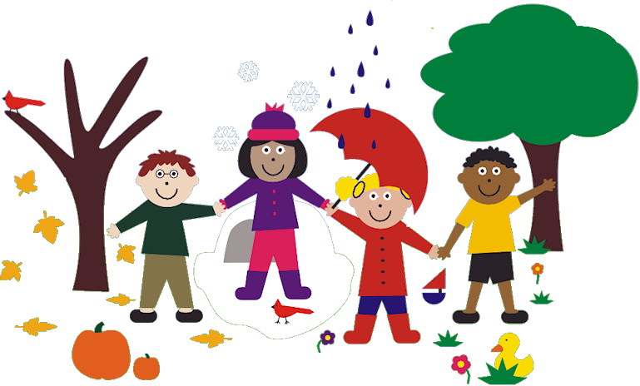

I sincerely hope you found this newsletter beneficial in understanding the importance of supporting young children develop their social skills in making relationships, how this looks in practice and how you as parents can help to support your child outside of the setting.

The next installment of the termly PSHE newsletter will focus on managing feelings and behaviour.

Kind Regards
Stacie Anthony-Phillips
Little Herons Nursery Manager

